**Name: Sudhan Kandel**

**Subject: Compiler and Construction Design**

**Lab-1**

**Q. Write a program to check whether the input is digit or not.**

**Program**

%{

#include<stdio.h>

#include<stdlib.h>

%}

%%

^[0-9]* printf("digit");

^[^0-9]|[0-9]*[a-zA-Z] printf("not a digit");

. ;

%%

int main()

{

// The function that starts the analysis

yylex();

return 0;

}

**OUTPUT**

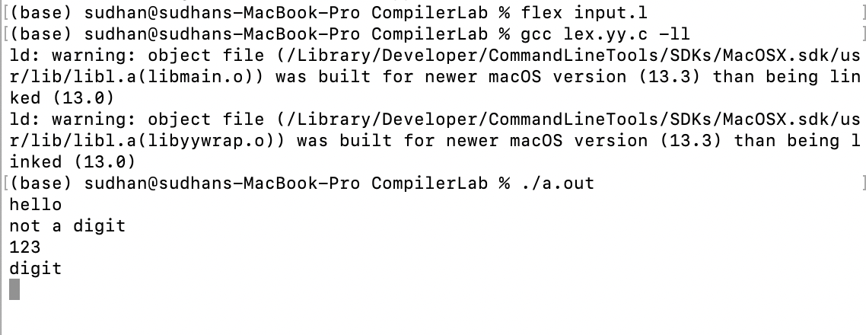

**Q. Write a program to identify tokens.**

**Program**

%{

#include<stdio.h>

%}

%%

bool|int|float printf("Keyword");

[-,+]?[0-9]+ printf("Constants");

[,.'"]+ printf("Punctuation Chars");

[!@#$%^&*()]+ printf("Special Chars");

[a-zA-Z]+ printf("Identifiers");

%%

int main()

{yylex();

}

**OUTPUT**

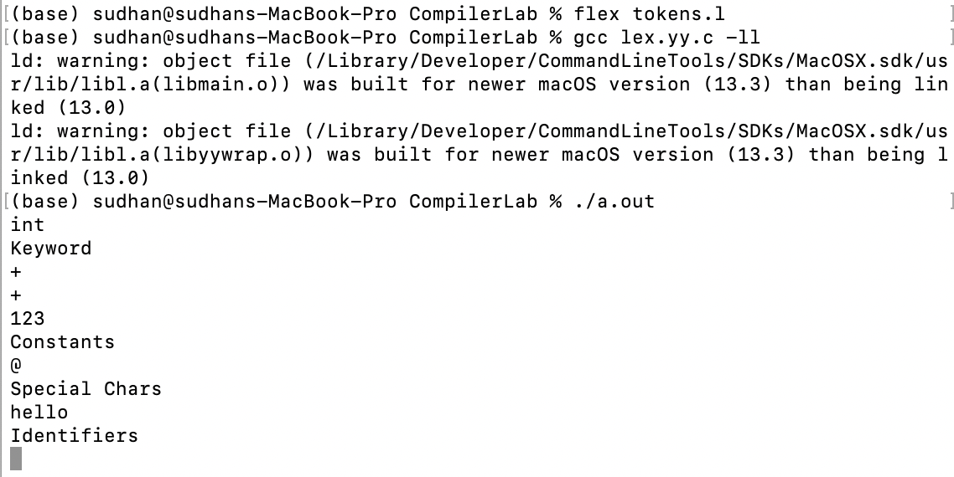

**Lab-2**

**Q. Write a program to DFA that accept string.**

1. **Baab**

**Program**

#include <stdio.h>

int main() {

char str[20], ch;

int i = 0, state = 0;

printf("Enter a string:");

scanf("%s", str);

while (str[i] != '\0') {

ch = str[i];

i++;

switch (state) {

case 0:

if (ch == 'b') {

state = 1;

} else {

state = 5;

}

break;

case 1:

if (ch == 'a') {

state = 2;

} else {

state = 5;

}

break;

case 2:

if (ch == 'a') {

state = 3;

} else {

state = 5;

}

break;

case 3:

if (ch == 'b') {

state = 3;

} else {

state = 5;

}

break;

case 5:

break;

}

}

if (state == 3) {

printf("The string is accepted");

} else {

printf("The string is invalid");

}

}

**OUTPUT**

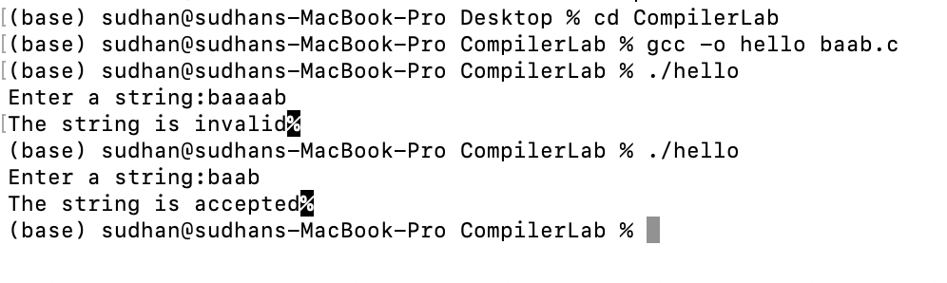

**b. abba**

**Program**

#include <stdio.h>

int main() {

char str[20], ch;

int i = 0, state = 0;

printf("Enter a string:");

scanf("%s", str);

while (str[i] != '\0') {

ch = str[i];

i++;

switch (state) {

case 0:

if (ch == 'a') {

state = 1;

} else {

state = 5;

}

break;

case 1:

if (ch == 'b') {

state = 2;

} else {

state = 5;

}

break;

case 2:

if (ch == 'b') {

state = 3;

} else {

state = 5;

}

break;

case 3:

if (ch == 'a') {

state = 3;

} else {

state = 5;

}

break;

case 5:

break;

}

}

if (state == 3) {

printf("The string is accepted");

} else {

printf("The string is invalid");

}

}

**OUTPUT**

**Lab-3**

**Q. Write a program to check valid identifier.**

**Program**

#include <stdio.h>

#include <ctype.h>

int main() {

char a[10];

int flag, i = 1;

printf("\n Enter an identifier:");

scanf("%s", a);

if (isalpha(a[0]) || a[0] == '_') {

flag = 1;

} else {

flag = 0;

}

while (a[i] != '\0') {

if (!isdigit(a[i]) && !isalpha(a[i]) && a[i] != '_') {

flag = 0;

break;

}

i++;

}

if (flag == 1) {

printf("\n Valid identifier");

} else {

printf("Not a valid identifier");

}

return 0;

}

**OUTPUT**

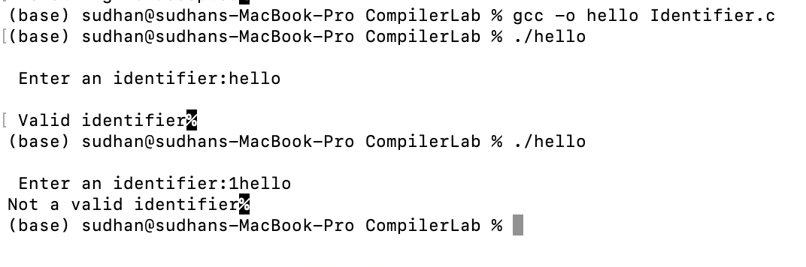

**Q. Write a program to check valid comment or not.**

**Program**

#include <stdio.h>

int main() {

char com[30];

int i = 2, a = 0;

printf("Enter comment:");

scanf("%s", com);

if (com[0] == '/') {

if (com[1] == '/') {

printf("\n It is a comment");

} else if (com[1] == '*') {

for (i = 2; i <= 30; i++) {

if (com[i] == '*' && com[i + 1] == '/') {

printf("\n It is a comment");

a = 1;

break;

}

}

if (a == 0) {

printf("\n It is not a comment");

}

} else {

printf("\n It is not a comment");

}

} else {

printf("\n It is not a comment");

}

return 0;

}

**OUTPUT**

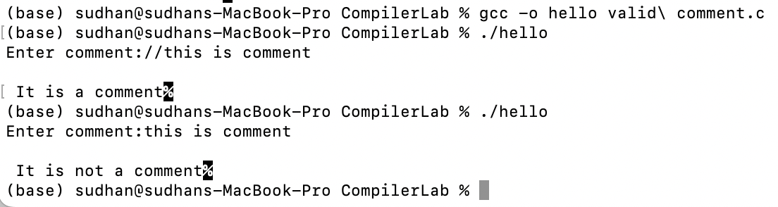

**Lab-4**

**Q. Write a program to count number of operators used in given input.**

a=b+c*d

**Program**

#include <stdio.h>

int count_operators(char *expression) {

int count = 0;

for (int i = 0; expression[i] != '\0'; i++) {

if (expression[i] == '+' || expression[i] == '-' || expression[i] == '*' || expression[i] == '/') {

count++;

}

}

return count;

}

int main() {

char expression[100];

printf("Enter an expression: ");

fgets(expression, 100, stdin);

int count = count_operators(expression);

printf("The number of operators in the expression is %d\n", count);

return 0;

}

**OUTPUT**

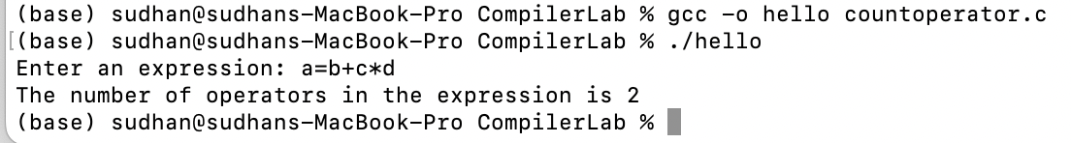

**Lab-5**

**Q. Write a program to find the first of given grammar.**

SL+R

SR

L*R

La

RL

**Program**

#include <stdio.h>

#include <ctype.h>

void FIRST(char[], char);

void addToResultSet(char[], char);

int numOfProductions;

char productionSet[10][10];

int main()

{

int i;

char choice;

char c;

char result[20];

printf("How many number of productions ? :");

scanf(" %d", &numOfProductions);

for (i = 0; i < numOfProductions; i++) //read production string e.g.: E=E+T

{

printf("Enter productions Number %d : ", i + 1);

scanf(" %s", productionSet[i]);

}

do

{

printf("\n Find the FIRST of :");

scanf(" %c", &c);

FIRST(result, c); //Compute FIRST; Get Answer in 'result' array

printf("\n FIRST(%c)= { ", c);

for (i = 0; result[i] != '\0'; i++)

printf(" %c ", result[i]); //Display result

printf("}\n");

printf("press 'y' to continue : ");

scanf(" %c", &choice);

} while (choice == 'y' || choice == 'Y');

}

void FIRST(char *Result, char c)

{

int i, j, k;

char subResult[20];

int foundEpsilon;

subResult[0] = '\0';

Result[0] = '\0';

//If X is terminal, FIRST(X) = {X}

if (!(isupper(c)))

{

addToResultSet(Result, c);

return;

}

//If X is non terminal then read each production

for (i = 0; i < numOfProductions; i++)

{

//Find production with X as LHS

if (productionSet[i][0] == c)

{

if (productionSet[i][2] == '$')

addToResultSet(Result, '$');

//If X is a non-terminal, and X → Y1 Y2 … Yk is a production, then add a to FIRST(X)

else

{

j = 2;

while (productionSet[i][j] != '\0')

{

foundEpsilon = 0;

FIRST(subResult, productionSet[i][j]);

for (k = 0; subResult[k] != '\0'; k++)

addToResultSet(Result, subResult[k]);

for (k = 0; subResult[k] != '\0'; k++)

{

if (subResult[k] == '$')

{

foundEpsilon = 1;

break;

}

}

//No e found, no need to check next element

if (!foundEpsilon)

break;

j++;

}

}

}

}

return;

}

void addToResultSet(char Result[], char val)

{

int k;

for (k = 0; Result[k] != '\0'; k++)

if (Result[k] == val)

return;

Result[k] = val;

Result[k + 1] = '\0';

}

**OUTPUT**

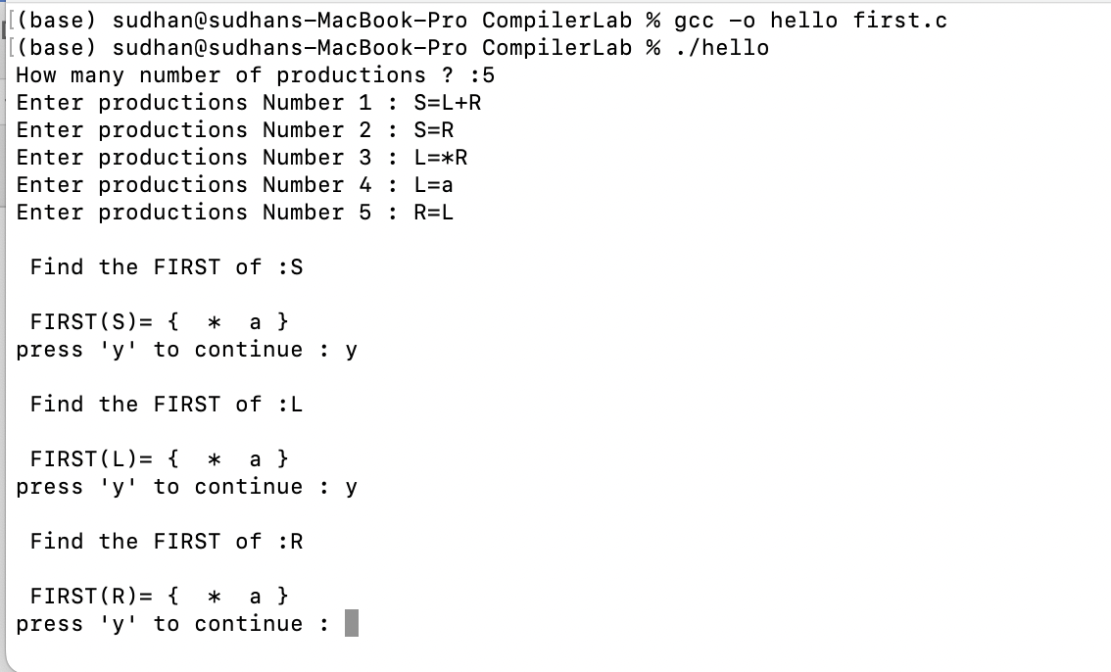

**Q.** Write a program to find the follow of the given grammar.

RaS

R(R)S

S+RS

SaRS

SaS

**Program**

#include <stdio.h>

#include <string.h>

#include <ctype.h>

int n, p, I = 0, j = 0;

char a[10][10], Result[10];

char subResult[20];

void follow(char *Result, char c);

void first(char *Result, char c);

void addToResultSet(char[], char);

int main()

{

int I;

int choice;

char c, ch;

printf(“Enter the no. of productions: “);

scanf(“%d”, &n);

printf(“ Enter %d productions\n Production with multiple terms should be give as separate productions \n”, n);

for (I = 0; I < n; i++)

scanf(“%s”, a[i]);

do

{

printf(“Find FOLLOW of ”);

scanf(“ %c”, &c);

follow(Result, c);

printf(“FOLLOW(%c) = { “, c);

for (I = 0; Result[i] != ‘\0’; i++)

printf(“ %c “, Result[i]);

printf(“ }\n”);

printf(“Do you want to continue(Press 1 to continue....)?”);

scanf(“%d”, &choice);

} while (choice == 1);

}

void follow(char *Result, char c)

{

int k;

subResult[0] = ‘\0’;

Result[0] = ‘\0’;

if (a[0][0] == c)

addToResultSet(Result, ‘$’);

for (I = 0; I < n; i++)

{

for (j = 2; j < strlen(a[i]); j++)

{

if (a[i][j] == c)

{

if (a[i][j + 1] != ‘\0’)

first(subResult, a[i][j + 1]);

if (a[i][j + 1] == ‘\0’ && c != a[i][0])

follow(subResult, a[i][0]);

for (k = 0; subResult[k] != ‘\0’; k++)

addToResultSet(Result, subResult[k]);

}

}

}

}

void first(char *R, char c)

{

int k, m;

if (!(isupperI) && c != ‘#’)

addToResultSet(R, c);

for (k = 0; k < n; k++)

{

if (a[k][0] == c)

{

if (a[k][2] == ‘#’ && c != a[i][0])

follow(R, a[i][0]);

else if ((!(isupper(a[k][2]))) && a[k][2] != ‘#’)

addToResultSet(R, a[k][2]);

else

first(R, a[k][2]);

for (m = 0; R[m] != ‘\0’; m++)

addToResultSet(Result, R[m]);

}

}

}

void addToResultSet(char Result[], char val)

{

int k;

for (k = 0; Result[k] != ‘\0’; k++)

{

if (Result[k] == val)

return;

}

Result[k] = val;

Result[k + 1] = ‘\0’;

}

**OUTPUT**

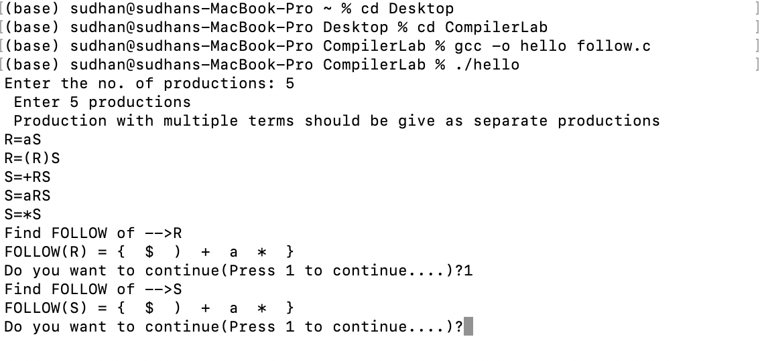

**Lab-6**

**Q. Write a program for constructing of LL (1) Parsing.**

**Program**

#include <stdio.h>

#include <string.h>

#include <process.h>

char s[20], stack[20];

int main()

{

char m[5][6][4] = {"tb", " ", " ", "tb", " ", " ", " ", "+tb", " ", " ", "n", "n", "fc", " ", " ", "fc", " ", " ", " ", "n", "*fc", " a", "n", "n", "i", " ", " ", "(e)", " ", " "};

int size[5][6] = {2, 0, 0, 2, 0, 0, 0, 3, 0, 0, 1, 1, 2, 0, 0, 2, 0, 0, 0, 1, 3, 0, 1, 1, 1, 0, 0, 3, 0, 0};

int i, j, k, n, str1, str2;

printf("\n Enter the input string: ");

scanf("%s", s);

strcat(s, "$");

n = strlen(s);

stack[0] = '$';

stack[1] = 'e';

i = 1;

j = 0;

printf("\nStack Input\n");

printf("__________________\n");

while ((stack[i] != '$') && (s[j] != '$'))

{

if (stack[i] == s[j])

{

i--;

j++;

}

switch (stack[i])

{

case 'e':

str1 = 0;

break;

case 'b':

str1 = 1;

break;

case 't':

str1 = 2;

break;

case 'c':

str1 = 3;

break;

case 'f':

str1 = 4;

break;

}

switch (s[j])

{

case 'i':

str2 = 0;

break;

case '+':

str2 = 1;

break;

case '*':

str2 = 2;

break;

case '(':

str2 = 3;

break;

case ')':

str2 = 4;

break;

case '$':

str2 = 5;

break;

}

if (m[str1][str2][0] == '\0')

{

printf("\nERROR");

exit(0);

}

else if (m[str1][str2][0] == 'n')

i--;

else if (m[str1][str2][0] == 'i')

stack[i] = 'i';

else

{

for (k = size[str1][str2] - 1; k >= 0; k--)

{

stack[i] = m[str1][str2][k];

i++;

}

i--;

}

for (k = 0; k <= i; k++)

printf(" %c", stack[k]);

printf(" \t\t");

for (k = j; k <= n; k++)

printf("%c", s[k]);

printf(" \n ");

}

printf("\n SUCCESS");

return 0;

}

**OUTPUT**

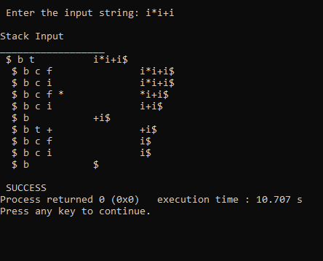

**Lab-7**

**Q. Write a program to implement Shift Reduce Parsing.**

EE+E

EE/E

EE*E

Ea/b

Input symbol a+b+a

**Program**

#include <stdio.h>

#include <stdlib.h>

#include <conio.h>

#include <string.h>

char ip_sym[15], stack[15];

int ip_ptr = 0, st_ptr = 0, len, i;

char temp[2], temp2[2];

char act[15];

void check();

void main()

{

printf("\n\t\t SHIFT REDUCE PARSER\n");

printf("\n GRAMMER\n");

printf("\n E->E+E\n E->E/E");

printf("\n E->E*E\n E->a/b");

printf("\n enter the input symbol:\t");

gets(ip_sym);

printf("\n\t stack implementation table");

printf("\n stack\t\t input symbol\t\t action");

printf("\n______\t\t ____________\t\t ______\n");

printf("\n $\t\t%s$\t\t\t--", ip_sym);

strcpy(act, "shift ");

temp[0] = ip_sym[ip_ptr];

temp[1] = '\0';

strcat(act, temp);

len = strlen(ip_sym);

for (i = 0; i <= len - 1; i++)

{

stack[st_ptr] = ip_sym[ip_ptr];

stack[st_ptr + 1] = '\0';

ip_sym[ip_ptr] = ' ';

ip_ptr++;

printf("\n $%s\t\t%s$\t\t\t%s", stack, ip_sym, act);

strcpy(act, "shift ");

temp[0] = ip_sym[ip_ptr];

temp[1] = '\0';

strcat(act, temp);

check();

st_ptr++;

}

st_ptr++;

check();

}

void check()

{

int flag = 0;

temp2[0] = stack[st_ptr];

temp2[1] = '\0';

if ((!strcmpi(temp2, "a")) || (!strcmpi(temp2, "b")))

{

stack[st_ptr] = 'E';

if (!strcmpi(temp2, "a"))

printf("\n $%s\t\t%s$\t\t\tE->a", stack, ip_sym);

else

printf("\n $%s\t\t%s$\t\t\tE->b", stack, ip_sym);

flag = 1;

}

if ((!strcmpi(temp2, "+")) || (strcmpi(temp2, "*")) || (!strcmpi(temp2, "/")))

{

flag = 1;

}

if ((!strcmpi(stack, "E+E")) || (!strcmpi(stack, "E\E")) || (!strcmpi(stack, "E*E")))

{

strcpy(stack, "E");

st_ptr = 0;

if (!strcmpi(stack, "E+E"))

printf("\n $%s\t\t%s$\t\t\tE->E+E", stack, ip_sym);

else if (!strcmpi(stack, "E\E"))

printf("\n $%s\t\t %s$\t\t\tE->E\E", stack, ip_sym);

else

printf("\n $%s\t\t%s$\t\t\tE->E*E", stack, ip_sym);

flag = 1;

}

if (!strcmpi(stack, "E") && ip_ptr == len)

{

printf("\n $%s\t\t%s$\t\t\tACCEPT", stack, ip_sym);

getch();

exit(0);

}

if (flag == 0)

{

printf("\n%s\t\t\t%s\t\t reject", stack, ip_sym);

exit(0);

}

return;

}

**OUTPUT**

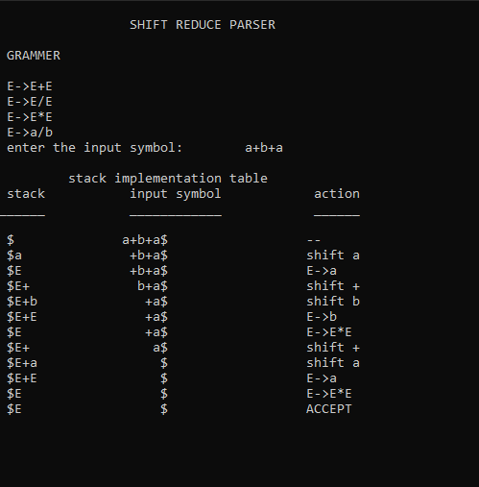

**Lab-8**

**Q. Write a program to implement intermediate code generation.**

X=a+b-c*d/e

**Program**

#include <stdio.h>

#include <string.h>

#include <process.h>

int i = 1, j = 0, no = 0, tmpch = 90;

char str[100], left[15], right[15];

void findopr();

void explore();

void fleft(int);

void fright(int);

struct exp

{

int pos;

char op;

} k[15];

int main()

{

printf("\t\t INTERMEDIATE CODE GENERATION\n\n");

printf("Enter the Expression :");

scanf("%s", str);

printf("The intermediate code:\t\t Expression\n");

findopr();

explore();

return 0;

}

void findopr()

{

for (i = 0; str[i] != '\0'; i++)

if (str[i] == ':')

{

k[j].pos = i;

k[j++].op = ':';

}

for (i = 0; str[i] != '\0'; i++)

if (str[i] == '/')

{

k[j].pos = i;

k[j++].op = '/';

}

for (i = 0; str[i] != '\0'; i++)

if (str[i] == '*')

{

k[j].pos = i;

k[j++].op = '*';

}

for (i = 0; str[i] != '\0'; i++)

if (str[i] == '+')

{

k[j].pos = i;

k[j++].op = '+';

}

for (i = 0; str[i] != '\0'; i++)

{

if (str[i] == '-')

{

k[j].pos = i;

k[j++].op = '-';

}

}

}

void explore()

{

i = 1;

while (k[i].op != '\0')

{

fleft(k[i].pos);

fright(k[i].pos);

str[k[i].pos] = tmpch--;

printf("\t%c := %s%c%s\t\t", str[k[i].pos], left, k[i].op, right);

for (j = 0; j < strlen(str); j++)

if (str[j] != '$')

printf("%c", str[j]);

printf("\n");

i++;

}

fright(-1);

if (no == 0)

{

fleft(strlen(str));

printf("\t%s := %s", right, left);

exit(0);

}

printf("\t%s := %c", right, str[k[--i].pos]);

}

void fleft(int x)

{

int w = 0, flag = 0;

x--;

while (x != -1 && str[x] != '+' && str[x] != '*' && str[x] != '=' && str[x] != '\0' && str[x] != '-' && str[x] != '/' && str[x] != ':')

{

if (str[x] != '$' && flag == 0)

{

left[w++] = str[x];

left[w] = '\0';

str[x] = '$';

flag = 1;

}

x--;

}

}

void fright(int x)

{

int w = 0, flag = 0;

x++;

while (x != -1 && str[x] != '+' && str[x] != '*' && str[x] != '\0' && str[x] != '=' && str[x] != ':' && str[x] != '-' && str[x] != '/')

{

if (str[x] != '$' && flag == 0)

{

right[w++] = str[x];

right[w] = '\0';

str[x] = '$';

flag = 1;

}

x++;

}

}

**OUTPUT**

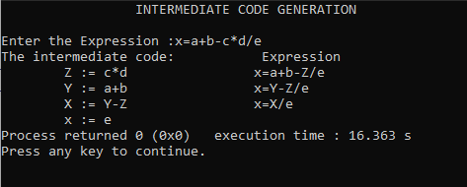

**Lab-9**

**Q. Write a program to implement machine code generation.**

**Program**

#include <stdio.h>

#include <string.h>

char op[2], arg1[5], arg2[5], result[5];

int main()

{

FILE *fp1, *fp2;

fp1 = fopen("input.txt", "r");

fp2 = fopen("output.txt", "w");

while (!feof(fp1))

{

fscanf(fp1, "%s%s%s%s", op, arg1, arg2, result);

if (strcmp(op, "+") == 0)

{

fprintf(fp2, "\n MOV R0,%s", arg1);

fprintf(fp2, "\n ADD R0,%s", arg2);

fprintf(fp2, "\n MOV %s,R0", result);

}

if (strcmp(op, "*") == 0)

{

fprintf(fp2, "\n MOV R0,%s", arg1);

fprintf(fp2, "\n MUL R0,%s", arg2);

fprintf(fp2, "\n MOV %s, R0", result);

}

if (strcmp(op, "-") == 0)

{

fprintf(fp2, "\n MOV R0,%s", arg1);

fprintf(fp2, "\n SUB R0,%s", arg2);

fprintf(fp2, "\n MOV %s,R0", result);

}

if (strcmp(op, "/") == 0)

{

fprintf(fp2, "\n MOV R0,%s", arg1);

fprintf(fp2, "\n DIV R0,%s", arg2);

fprintf(fp2, "\n MOV %s,R0", result);

}

if (strcmp(op, "=") == 0)

{

fprintf(fp2, "\n MOV R0,%s", arg1);

fprintf(fp2, "\n MOV %s,R0", result);

}

}

fclose(fp1);

fclose(fp2);

return 0;

}

**OUTPUT**

**Input**

